**How to cope with failure**

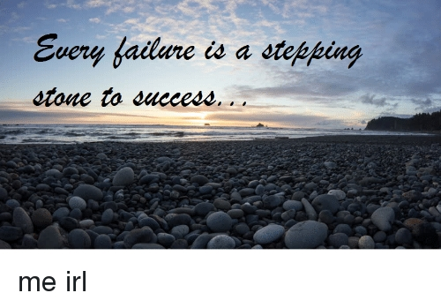

“Failure is not a thing of a shame, it is a proof of you efforts” . Everyone has face failure at least one time in their lives. No one is perfect in this world. People do mistakes, and learn from them. Failure is not the problem. But when you do not learn anything from it , then there is problem. We all are human, we are meant to do mistakes, but we also need to learn from our mistakes, try to improve ourselves.

But sometimes we don't know how to deal with our failure. Some people react positively, learn from their failure and start improving themselves . But some people start thinking that their failure is the proof that they fail in their lives . This is not the truth. One failure in life can't make our whole life worthless. It's just a failure, we can try that thing again and get success in it. We only need to learn two things:- 1. How to cope with our failure, and 2. Try to improve ourselves.

Here are some ways to cope with our failure:

* **Don't Escape from your Emotion**

Failure is full of emotions like anxiety, embarrassment, shame and sadness. Don't try to escape from these emotions. Feeling these emotions can motivate you. It helps you to work harder and better. You can easily improve yourself. So go and embrace your emotions , feel them for a while and come back with improvements and full dedication.

* **Discuss your feelings with someone**

When you feel sad; failed ; or depressed , share your feelings with someone who you think understands you. Don't kept your feelings inside yourself. This can give way to negative thoughts and self destruction. Always try to share what you feel. This make you feel better and relaxed. Sharing of feelings help you to see things with different prospective and motivate you to become better and do better.

* **DON'T think you are a Failure**

Whenever you had a setback , you start feeling that you can't do anything in that field. You always face failure in that area. But that's not the truth. It's just that you can't get success in the particular field, you are a failure. **NO, YOU ARE NOT A FAILURE.** Don't get these kind of thoughts in your mind. Instead of tell yourself that if you failed once its not that you'll also be fail in future. Be realistic, your life can't get stop because of one failure, just keep moving forward, keep learning from your mistakes, improving yourself and become better.

* **Remember that Failure is a part of Success**

Always keep it in your mind that failure not the end , it is the stepping stone to success. Every successful person has face the setbacks in his journey of success but he believes in himself and keeps improving him to achieve his goal and at last they get success.

All of you know the inventor of bulb **THOMAS ELVA EDISON.** He got failed in his invention of bulb 1000 times but he never give up, keep try and improving , eventually he got successful. Now he is known as a great scientist who invented bulb. So never think that failure stops the way of your success, it makes you one step closer to your success.

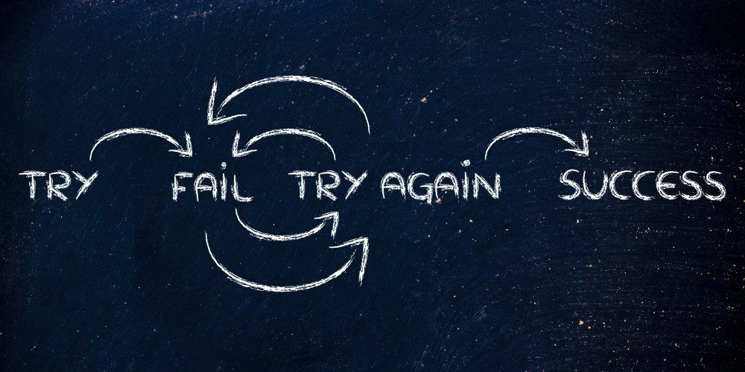

* **Learn from your Setbacks**

Try to learn from your setbacks. Start improving the things. Start question yourself that

-what is the most important thing that you need to learn from this mistake?,

-how can you improve it and make it successful?,

- what changes you need to do?

- what kind of plans and strategies you need to adopt?

These kind of questions help you to start believing in yourself. Self questioning helps to regain your confidence. You got all the answers of your questions that comes in your mind when you are sad . This helps you to find more improved and innovative changes that makes you closer to your success.

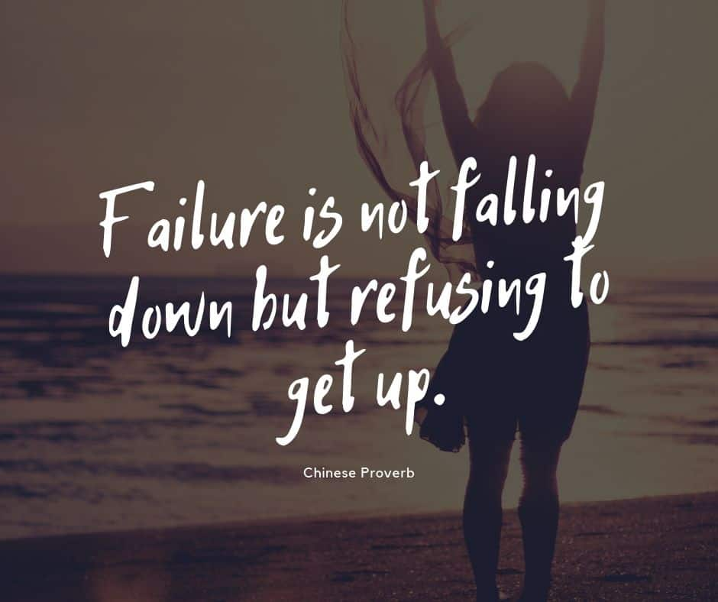

So , start thinking positively . Failures or setbacks are the part of our lives. They teach us the value of success. Failures make our success more fruitful. Never think that your setbacks make you worthless or you never achieve success ; your setbacks makes you a step forward to your success , all you need to do is to learn from them and make improvements that's it.